Department for Environment, Food and Rural Affairs
Practitioners’ handbook for low cost repairable or resilient reinstatement.

Date in format: September 2017
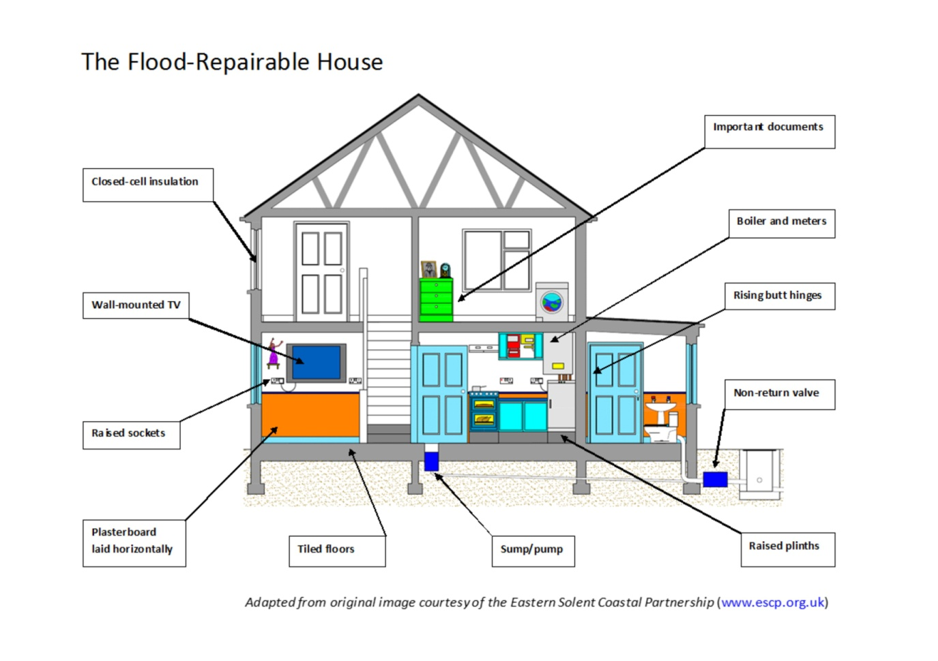
Contents
Introduction…………………………………………………………………………………………2
Overview of low cost flood repairable approach………………………………………………..2
Appendix 1: List of low cost repairable approaches……………………………………………4
Appendix 2: Checklist for surveyors …………………………………………………..…….......9
Appendix 4: Resilient and repairable Kitchens…………………………………………………
Appendix 5 Information for Householders…………………………………………………….
Appendix 3: Further sources of information ……………………………………………….…..11

Property Level Flood Resilience
The presence of a community flood structure does not mean that people will never be flooded: there is always a residual risk.
Flood resilient communities are places where local people are aware of their flood risk; know what this means for them, their property, and they have the confidence and ability to cope with events.
The aim is to get people to a point where they can manage the consequences of flooding, including the cost and duration of any future repair, if flooding were to re-occur. PLR brings together a range of behaviours, actions and measures that together, will help people become more resilient to the impacts of flooding.
From a commercial perspective, resilience reduces the cost of repair and the time that people are out of a property, in any future flood event.

Working with Householders
Use of resilient elements to replace elements susceptible to damage from floodwaters should be treated as a routine part of the repair process for property at continued risk of flooding.
Householders should in general always be made aware where resilient alternatives have been used as part of the repair: particularly where householders will need to make minor changes to routine household activities (type of paint used for redecoration, for example).
Appendix 5 has information that the practitioner can print off and share with owners of properties undergoing repair.

Introduction

What is this guide?
This handbook provides a summary of measures that may be used to limit damage once floodwater enters a property. The measures have been identified within the Defra technical evidence review as part of the Defra research project FD2682. This review drew on existing guidance, professional and practitioner experience and the evidence from a small number of households that have had measures installed in the past. There are many more approaches that can be used than are included in this handbook (see information sources below). The measures included here have been assessed to have the potential to be installed at no, or no significant, extra cost over like for like reinstatement in different types of property typically found in the UK.

What is the purpose of the guide?
The handbook is designed to be a convenient summary of potentially appropriate alternative approaches to reinstatement that will reduce the cost and disruption of future flood damage. It includes a checklist for surveyors to use in informing their discussion with flood affected households and small businesses during the reinstatement process. This handbook is not designed to be a comprehensive technical manual, as most of the approaches and materials described within this handbook are within the technical competencies of building surveyors. It is intended to highlight those approaches meriting consideration when dealing with flooded properties that are likely to flood again in the future.
The suitability and cost of the different approaches listed here will vary significantly for each individual property, flood risk situation and householder or business owner. This handbook provides a range of approaches that are considered to be low cost options. It is envisaged that surveyors will use their professional judgement and to determine the best and most cost effective reinstatement plan for each property.
Overview of low cost flood repairable approach
Flood resilient reinstatement or resilient repair means reconstructing or reinstating a flood damaged building in such a way that, although floodwater may enter the building, its impact is reduced, i.e. no permanent damage is caused, structural integrity is maintained and drying and cleaning are facilitated quicker when the flood water has receded.
The approach is suitable for any building at risk of flooding even if the intention is to keep water out because measures may be overtopped or fail. However resilient reinstatement is commonly used as part of a wet proofing or water entry strategy for buildings that can include:
- flood-resilient material and designs;
- sacrificial approaches;
- consideration of hydrostatic pressures/impact loads on structures;
- consideration of how the water will be allowed to enter a property, means of escape for the building occupants and security of building contents during and after a flood;
- drying plan - designs to drain water away after flooding and access to all spaces to allow drying and decontamination;
Flood resilience within a building can be achieved in different ways:
- Vulnerable elements (such as electrics) can be raised above the expected flood level or removed (avoidance);
- Exposed elements can made of, or coated in, flood resistant materials (for example use of ceramic tiles, water resistant paint or varnish, plastic skirting); or
- Exposed elements can be made of resilient materials that can accept water without deformation or disintegration and dry quickly afterwards with potential for decontamination (for example cementitious materials)
- Deliberate choice of low cost, easily replaced, sacrificial elements.
In all cases the need to evacuate the water quickly is important. For resilient materials the adequate strategy for creating the conditions to dry the materials is key to a quick return to the property
A range of measures can be used to make a property resilient to damage from floodwater and those used will depend on the nature of the property and the flood risk it faces. The diagram on the front cover illustrates some of the approaches and a list of potential low cost approaches is set out in Appendix 2.

Kitchens
One of the key areas in anyone’s property is the kitchen. There are a range of options that can pursued, including some which will make it flood resilient. A detailed guide has been included with this document at Appendix 4.

© Crown copyright [2017]
You may re-use this information (excluding logos) free of charge in any format or medium, under the terms of the Open Government Licence v.3. To view this licence visit www.nationalarchives.gov.uk/doc/open-government-licence/version/3/ or email PSI@nationalarchives.gsi.gov.uk
This publication is available at www.gov.uk/government/publications
Any enquiries regarding this publication should be sent to us at [insert contact details]
This handbook was prepared as part of the Defra Project FD2682 by Jessica Lamond, UWE Bristol; Rotimi Joseph, Cunningham Lindsey; with input from Robbie Craig, Defra, Stephen Garvin, BRE; Ian Gibbs, Cunningham Lindsey; Carly Rose, UWE Bristol.

List of suggested low cost measures for water entry strategy
MEASURE TYPE | Depth | SPECIFIC interventions
Depth Key: Low= up to 100mm; Medium= up to 300mm; High= up to 900mm; Any= up to one storey
Low cost: is defined as having the potential to represent low additional cost at reinstatement and this judgment may vary depending on the specification of the original elements being replaced
Water compatible walls | High | Fix plasterboards horizontally on timber framed walls rather than vertically (aka Sacrificial plaster board/dry-lining)
 | Any | Removable timber cladding material
 | Any | Cement Render/cement sand render/water-resistant cement-based plaster coated on to internal walls then skimmed
 | High | Ceramic/porcelain tiles (with water-resistant grout and adhesives, as used in swimming pools). This can only be low cost if it is specified to replace an existing expensive floor carpet.
 | Any | Closed-cell type insulation (to replace mineral insulation in cavity walls) (aka Sprayed polyurethane foam or SPF)
 | Any | Cavity wall – use insulation materials that are water resistant/low absorption (expanded polystyrene sheets, EPS water-resistant beads, or semi-rigid self-draining mineral wool slabs/batts that will not collapse on wetting) with stainless steel fixings
 | Any | Replace corroded timber frames with treated timber
 | Any | Replace corroded steel frames with galvanised steel equivalents
 | High | Seal between wall, floor and partitions (continue concrete seal 0.5m up walls)
 | Any | Avoid (non-breathable) vinyl wall-coverings, use microporous paint temp finish, then paper (breathable wallpapers must be affixed with breathable adhesives)
Water compatible floors | Any | Avoid fitted carpets, parquet and laminate flooring: use ceramic tiles, loose fitting rugs; removable carpets (e.g. fixed with Velcro or hooks-&-eyes set into floors)
 | Any | Quarry tiles, coated to prevent staining
 | Any | Cement-rich screed
 | Any | 3mm epoxy resin waterproof floor treatment added to concrete flood screed
 | Any | Suspended floors - preservative-treated joists/ floorboards
 | Any | Ensure effective connection between the damp-proof membrane for the floor and the damp proof course in the wall
 | Any | If oak blocks on concrete need replacing, use tiles. If oak blocks set in bitumen need replacing, then use screed and new finish on top.
 | Any | For suspended floors, if oak floorboards need replacement, then use (cheaper) treated timber.
 | Any | Remove ash-bedding from underneath quarry tiles in Victorian houses (retains moisture and impedes drying out)
 | Any | Clear and repair air bricks/vents to suspended timber ground floors (aids drying out process via airflow imps)
 | Any | Closed cell insulation in boards for floors
Water compatible kitchen fittings | Low | Fit kitchen units with extendable plastic or stainless steel feet or support on raised brick/stonework (for floods
 | Any | Specify the least expensive kitchen possible and to expect to replace it (aka Sacrificial approach)
 | Any | Free standing removable units (e.g. pitch pine), then carry upstairs when flood warning rec'd.
 | High | Limit number of base units and have removable doors so only bottom carcases need replacing
 | Medium | Avoid built in appliances and have strong work surfaces that can support appliances during a flood
 | Low | Removable kick boards – wrapped around units avoiding end sections that extend to the floor
 | Medium | Better to have a table and/or high-level ‘breakfast bar’ than a (fixed) island.
 | Any | Avoid kick heaters and use radiators instead.
Water compatible bathroom fittings (ground floor/ basements) | Any | Waterproof tile adhesive and water-resistant grout for tiled walls
 | Any | Some acrylic baths have integral encapsulated (i.e. waterproofed) base-boards (cost same as normal acrylic baths).
 | Any | Use of an anti-siphon toilet
 | High | No vanity unit around wash-hand basin use wall mounted cupboards/shelves
 | Medium | Sump and pump system ( with alarm in case pump fails)
Building Services | Medium | Raised electrics = dual purpose, as more accessible for older/less mobile people when raised.
 | High | Electric cables drop from first-floor level down to sockets at high level on walls;
 | Any | Central heating pumps and controls raised above max expected flood level; and any pipe insulation below exp'd flood level replaced by closed-cell type
 | Any | CH control unit moved upstairs, so radiators serving upper floor(s) can still be used (ground floor underfloor heating only).
 | Any | Wall-hung fires >1m above flood level (depends on expected flood depth)
 | Any | Raised meters 1m above expected flood level, and use plastic housing.
 | Any | Boiler mounted above max expected flood level
 | Any | Seal radiators with polyethylene sheeting
 | Any | Where possible, incoming telephone lines/cable services/ and internal control boxes should be raised above the expected flood levels.
 | High | Through-wall service connections raised >900mm above the ground floor level
 | Any | A house can be wired so that the ground floor ring main can be switched off, leaving supply to the upper floors still available; likewise, smaller vulnerable circuits can be isolated.
 | Any | Place services including electrics in easy to access conduits to allow draining and drying
 | Any | Anti backflow devices on foul drainage
 | Any | Anti-backflow valves (NRVs) to sewer pipework AND dishwasher/washing machine pipes.
 | Any | Toilet 'bungs' (e.g. Panseal); sink and shower 'bungs' (to prevent sewage ingress)
 | Any | Water supply pipework insulation can be replaced with flood resistant closed cell material below the expected flooding level.
Doors/windows/staircases | Medium | Separate piece of carpeting for bottom-most stairs, removable when flood warning received - then nail back down (but looks like normal fitted stair carpet).
 | Any | Replace internal doors with solid hardwood doors (caution - avoid cheap 'oak-style' doors)
 | Any | Consider installing cheapest possible doors to be sacrificial.
 | Any | Removable /light weight internal doors/Replace door hinges with rising butt hinges. These allow doors to be lifted off.
 | Any | Retain traditional solid wood doors, on rising butt hinges, and use on trestles to support furniture etc
 | Any | For wooden windows and external doors - use oil-based or waterproof stains, paint or varnish timber
 | Any | Replace doors, windows, skirting boards, architraves, doorframes and window frames with fibreglass (GRP), PVC-U or similar
 | Any | Replace skirting boards with ceramic tiles
 | Any | Treat wood skirting, painted on ALL sides
 | Any | Oak skirting held with screws, removable.
 | Any | Use of toughened glass in doors/windows /cabinets (reduce damage from floating debris)
 | Any | Use non-corrosive door/window hardware fittings (eg stainless)
 | Low | Wall cupboards/built-in-wardrobes - rebuild off floor with plastic legs, concealed by removable plinth
 | Any | Use PVC wall cupboards instead of timber
 | Any | Bookcases formed of fixed brackets but with easily removed shelving.
 | Any | Oak exterior doors oiled repeatedly with linseed oil
Contents Protection | Low | Plinths (or equivalent methods) for white goods
Miscellaneous | Any | Ext walls - Re-point brickwork with a mix of 1:2:9 – cement: lime: sand mortar (far more likely to survive flood conditions without need for repair)

SURVEYOR’S CHECKLIST FOR FLOOD RESILIENT RECOVERY
Property Address:……………………………………………………………………………………..
Date:…………………………………………………………………………………………….
 | Current option | Resilient choice
Change Room usage
Wall plaster type
External walls
Internal walls
Floor finishes
Kitchen
Bath/cloakroom
Entrance hall
Reception room
Reception room 2
Other
Other
Wall Finishes
Kitchen
Bath/cloakroom
Entrance hall
Reception room
Reception room 2
Other
Other
Internal doors

Skirting board

External doors

Staircase
Windows
Electric sockets positions
Phone socket position

Boiler position

Meters position

Change kitchen type or use resilient design features
Use resilient features bath/cloakroom
Insulation
TV and other tech positions
Fitted cupboard/bookshelves
Lightweight furniture
Kitchen
Reception room
Reception room 2

Further sources of information
Relevant standards include:
BS 85500, Guide to Improving the Flood Performance of Buildings
(note that a core standard document is available to download free of charge.
http://shop.bsigroup.com/ProductDetail/?pid=000000000030299686.)
Flood products should meet PAS1188 Flood Protection Products. Specification. Building Aperture Products or similar standards.
http://shop.bsigroup.com/ProductDetail/?pid=000000000030287158
The handbook and documents above drew on several key existing guidance documents for suggested approaches:
• GARVIN, S., REID, J. & SCOTT, M. 2005. Standards for the repair of buildings following flooding. London: Construction Industry Research and Information Association CIRIA
• ASSOCIATION OF BRITISH INSURERS 2003. Assessment of the cost and effect on future claims of installing flood damage resistant measures. London: Association of British Insurers.ABI
• DHONAU, M. & ROSE, C. B. 2014. Homeowners' guide to flood resilience (3rd edition 2014) [Online]. Know Your Flood Risk Campaign. Available: http://www.knowyourfloodrisk.co.uk/sites/default/files/FloodGuide_ForHomeowners.pdf 2014].
- BRE Good Building Guide (GARVIN S and HUNTER K), Applying flood resilience technologies (GG 84), 1984 (www.brebookshop.com)
- BRE Digest 523 (GARVIN S): Flood-resilient building (www.brebookshop.com)
  - Part 1 – Legislation, planning, flood-risk assessment and performance of buildings DG 523-1 (2012)
  - Part 2 – Building in flood-risk areas and designing flood-resilient buildings DG 523-2 (2012)
- BRE Good Repair Guide 11, Repairing flood damage, 1997.

© Crown copyright [2017]
You may re-use this information (excluding logos) free of charge in any format or medium, under the terms of the Open Government Licence v.3. To view this licence visit www.nationalarchives.gov.uk/doc/open-government-licence/version/3/ or email PSI@nationalarchives.gsi.gov.uk
This publication is available at www.gov.uk/government/publications
This handbook was prepared as part of the Defra Project FD2682 by Jessica Lamond, UWE Bristol; Rotimi Joseph, Cunningham Lindsey; with input from Robbie Craig, Defra, Stephen Garvin, BRE; Ian Gibbs, Cunningham Lindsey; Carly Rose, UWE Bristol.

Publishing Organisation
Department for Environment, Food and Rural Affairs
Flood Risk Management Division,
Nobel House,
17 Smith Square
London SW1P 3JR

